OMNIA RETAIL POS
Point of sale, stock and billing system
Store Administrator Operating Guide
Catalogue, stock and billing — day-to-day operations

Prepared for: Store Administrator
Version 1.0 | 30 September 2026
Confidential — internal circulation only

Document control
Field | Detail
Title | Store Administrator Operating Guide
Version | 1.0
Date of issue | 30 September 2026
Prepared by | IT / Implementation team
Applies to | Omnia Retail POS — browser and Windows desktop application
Next review | On the next major release

Contents

1. About this guide
This guide covers the running of a single store: the product catalogue, receiving and controlling stock, billing customers, handling returns and reading the daily reports. Everything described here applies to your own store only — other branches' figures are never visible to you.
Company-wide setup such as creating stores, storage locations, tax rates and numbering is handled by the Super Administrator before the store opens. If something in that list needs to change, raise it with them rather than working around it.

Sign-in details
Role | Email | Password | Store
Store Administrator | omnia-storeadmin@gmail.com | omnia@123 | Omnia

Change this password after your first sign-in, and turn on two-step verification from Settings if the shop handles credit customers.

2. Signing in
Open the Omnia POS desktop application on the counter, or the web address in a browser, and sign in. Pick the current financial year when prompted.
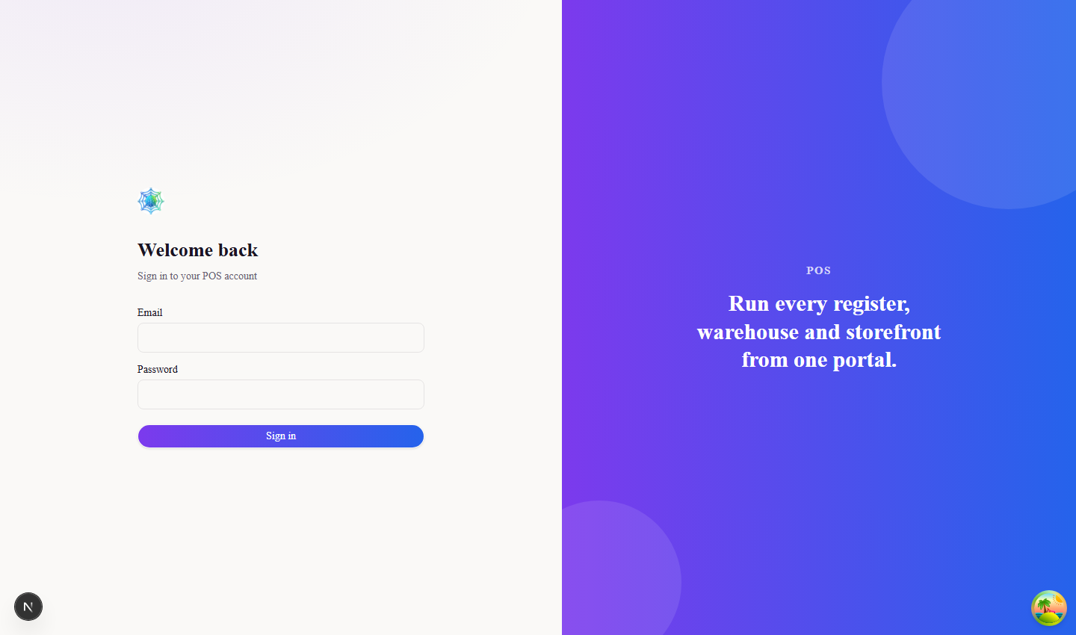
Figure 1. Sign-in screen

Dashboard
The dashboard is the landing page. It gives the day's position at a glance and quick links into the screens used most often.

3. Setting up the catalogue
Do this once, before the first sale. Products cannot be billed until they exist with a price and, where GST applies, an HSN code.

3.1 Categories
Categories group products for searching and reporting — snacks, beverages, stationery and so on.

3.2 Units of measure
Units describe how an item is sold: piece, kilogram, litre, box.

3.3 Products
Each sellable item is one product record, carrying its price, unit, category, HSN code and reorder level. Sell the same item in two pack sizes and you create two products, not one with options.
Tick Stock tracked for anything you want counted. Items left untracked can still be billed but will never appear in stock reports or low-stock warnings.

3.4 Barcodes
Every product is given a system barcode when it is saved. Print labels from here for loose items, or for anything that arrived without a manufacturer barcode.

4. Customers and suppliers
Walk-in sales need no customer record. Create one when a customer buys on credit, collects loyalty points, or wants a GST invoice in their firm's name.
Suppliers are the parties stock is bought from, and are selected when raising a product request or receiving goods.

5. Bringing stock in

5.1 Opening balance
Use this once, when the store starts using the system, to record what is already on the shelves. Enter the quantity held for each product against its storage location.

5.2 Product requests
A product request is the order placed on a supplier. Record what was asked for and from whom; the quantities are then carried forward when the goods arrive.

5.3 Stock inward
Stock inward is the goods-receipt entry, and it is what actually increases stock. Record the quantity accepted and, separately, anything rejected on inspection.
Where the goods arrived against a product request, pick it up with Select pending request and the outstanding quantities are filled in for you. Accepted plus rejected can never exceed what is still outstanding.

6. Controlling stock

6.1 Damage
Record breakages, expiry and anything else that leaves the shelf unsellable. The quantity is taken out of stock against a reason code.

6.2 Blocks
Blocking sets stock aside without selling it — goods promised to a customer, or held back pending a check. Blocked quantity stays in stock but cannot be billed.

6.3 Transfers
Move stock between your own storage locations, or send it to another branch. A transfer to another store is held as a request until that store accepts it, and the quantity stays blocked at your end in the meantime.

6.4 Adjustments
After a physical count, correct the difference with an adjustment — positive when more was found than the system shows, negative when less. Every adjustment needs a reason code, and the reason is what the auditor will read.
A negative adjustment cannot take stock below what is actually available; the entry is refused rather than allowed to go negative.

6.5 Quality check
Record a re-test on stock that was set aside. Anything that fails is written off as damage automatically, so there is no second entry to make.

6.6 Low stock
This list shows everything at or below its reorder level for the chosen storage location. Work from it when placing the next order.

7. Billing
New Bill is the selling screen. Scan or search to add items, set the quantity, apply any discount, take the payment and complete the sale. A bill can be saved as a draft or put on hold if the customer steps away, and picked up later from the draft or held list.
Cash bills are settled at the counter. A credit bill can be completed without payment and collected later. Where the customer pays by QR, payment link or card machine, raise the request from the same screen and the bill closes once the payment is confirmed.
A completed bill can still be corrected for two hours after it is raised — open it and choose Edit. After that window the bill is final and a return or cancellation is the only route.

8. Returns, credit notes and refunds
Start a return from the bill the goods were sold on, and state for each line whether the item came back sellable or damaged; only sellable stock goes back on the shelf.
Settle the return either as a credit note, which reduces what a credit customer owes, or as a refund, which pays money back. A walk-in customer with no record can only be refunded.

9. Shifts and cash
Open a shift at the start of the counter's day with the float in the drawer, and close it at the end by counting the cash. The system works out what should be there from the sales and refunds recorded, and shows the difference.

10. Reports
Reports are read-only and always scoped to your own store.

11. Adding your own staff
You can create the accounts your store needs without going back to head office. Use Manager for someone who runs the floor and handles stock, and Cashier for someone who only bills.
You cannot create another Store Administrator or reach company-level settings. Anyone leaving should be deactivated the same day rather than deleted, so their past entries stay traceable.

12. Daily routine
When | What to do
Opening | Sign in, open the shift with the cash float in the drawer
During the day | Bill customers; record damage as it happens, not at the end
On delivery | Enter stock inward against the supplier or product request
Before closing | Check the low-stock list and raise product requests
Closing | Count the cash and close the shift; look at the day's sales report

Anything this guide does not cover — a new storage location, a change to tax rates, a new bill format — sits with the Super Administrator. Raise it with them rather than working around it.

